AUTOMATION TESTING USING SELENIUM TOOL FOR ONLINE FOOD APPLICATION

M.GEETHA SRI 192110718

AIM:

To execute Automation testing using Selenium tool for online food application

PROGRAM :

package chennai;

import org.openqa.selenium.By;

import org.openqa.selenium.WebDriver;

import org.openqa.selenium.WebElement;

import org.openqa.selenium.chrome.ChromeDriver;

//import org.testng.Assert;

//import org.testng.annotations.Test;

public class sellinium1

{

public static void main(String[] args)

{

System.out.println("hai");

System.setProperty("webdriver.chrome.driver","C:\\manik\\CSA37 Lab

details\\Sellinium and junit\\selenium jar\\chromedriver_win32\\chromedriver.exe");

WebDriver driver = new ChromeDriver();

//driver.get("https://www.google.com/"); driver.manage().window().maximize(); driver.get("https://life.saveetha.com");

WebElement username=driver.findElement(By.id("txtusername"));

System.out.println(username);

WebElement password=driver.findElement(By.id("txtpassword"));

System.out.println(password);

WebElement login=driver.findElement(By.name("btnlogin"));

System.out.println(login);

username.sendKeys("192110718");

password.sendKeys("GEETHA@123");

login.click();

}

}

OUTPUT:

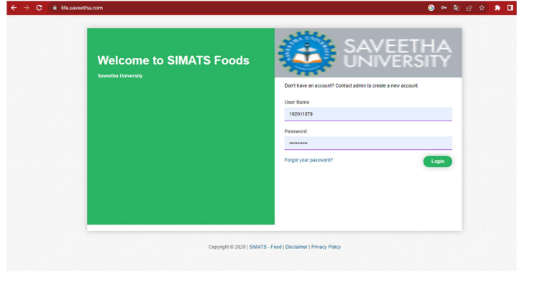

RESULT:

Hence Automation testing for online food application is Executed successfully.